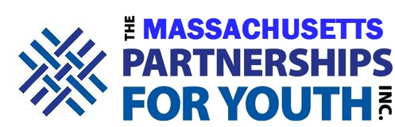

School Safety – Best Practices from the FBI

Wednesday, November 20, 2019

Assabet Valley Technical High School
Agenda

8:45 am – 9:00 am Welcome and Introductions
Margie Daniels, M.Ed., L.I.C.S.W.
Executive Director, Massachusetts Partnerships for Youth

9:00 am – 9:10 am Prioritizing School Safety at the State House
James Eldridge, Massachusetts State Senator, Middlesex and Worcester
Kate Hogan, Massachusetts State Representative, 3rd Middlesex

9:10 am – 9:20 am Massachusetts Partnership Award
Brooke Clenchy, Ed.D., Superintendent, Nashoba Regional School District

9:20 am – 9:50 am Reflections on School Safety
Terrence Reidy, Undersecretary in Law Enforcement, Massachusetts Executive Office of Public Safety & Security

9:50 am – 10:15 am Decision Making in a Multidisciplinary Environment
Richard Smith, Wakefield Police Chief, Ret., Chair, Massachusetts Partnerships for Youth Board of Directors

10:15 am – 10:30 am Discussion Break

10:30 am –11:30 am Realities of Bomb Threats
Brian Leblanc, Special Agent, Massachusetts Office of the Federal Bureau of Investigation

11:30 am – 12:30 pm Bombs: Threat Assessment
Sgt. William Qualls
Massachusetts State Police Bomb Squad

12:30 pm – 1:00 pm Lunch

1:00 pm – 2:30 pm Cyber Investigation
Tom Doyle, FBI Intelligence Analyst

2:30 pm Adjourn

